Manual Fuel Surcharge Maintenance v-8.2.1.007

Open Any Carrier Maintenance window in the desk top application. Click on “Nat Fuel Index” button in the ribbon bar.

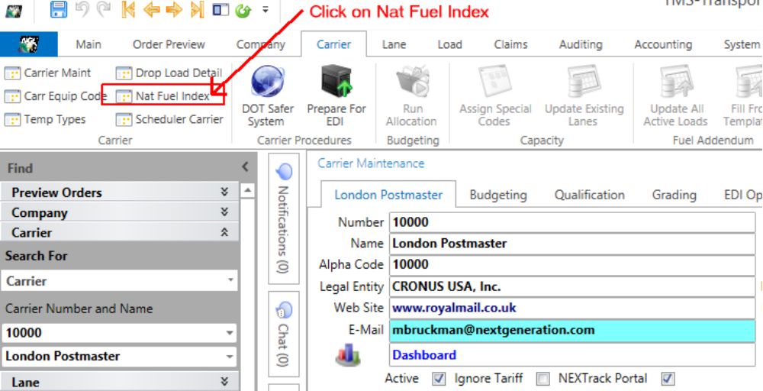
This will open the “DOE Fuel Index” dialog
Notice the zones. Your fuel surcharge will use one of the zones as configured in the Nat Fuel Zone data.
Click on the “Nat Fuel Zones” button to review your settings.
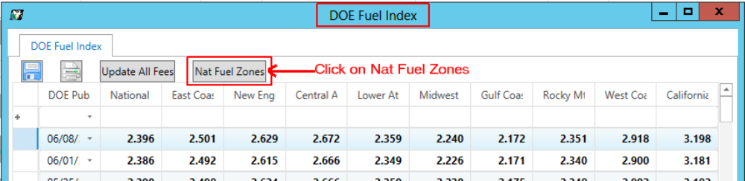
Add States or Provinces to the desired Zones. To save changes for each state or Provence tab through each field and press enter. Mod Data and Mod User are inserted automatically and will update the next time the screen is opened.
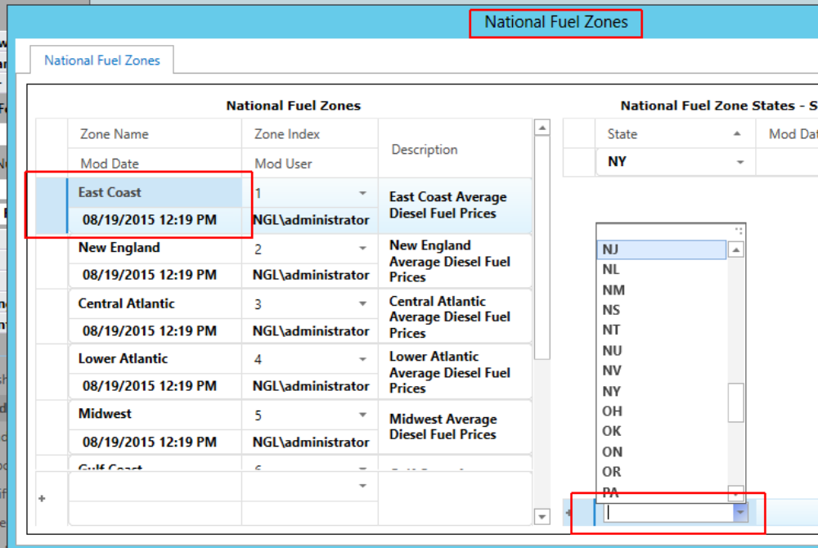

Fuel Rates will be applied based on the National Average or by the matching Zone fuel prices. Note that Zones only need to be configured once for all carriers and locations. Zone settings will apply to all locations/warehouses/Companies.
Close the “National Fuel Zone” dialog and return to the “DOE Fuel Index”. To manually update the Fuel Index, enter a new DOE Pub Date for when this rate will go into effect. Effective dates are based on the Planned to Load Date in TMS.
Enter a fuel prices for the National Average and all the zones. You may enter the same fuel price for more than one Zone, but each zone must have a value.
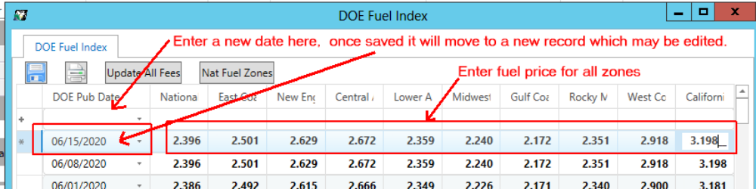
Once all your fuel prices have been entered run “Update All Fees” to update fuel rates and all active loads.
